FA-9

Espiritu, Joseph Raphael M. Clores, Harneyyer Leosara

2025-05-07

#### **1. Campus Normal Distribution**

* Sleep Hours of College Students

#### **2. Data**

* Sleep Time (Hours) (60 Participants) - { 7, 7, 5, 6, 6, 6, 5, 6, 6, 6, 6, 8, 6, 6, 9, 7, 7, 9, 7, 8, 8, 7, 7, 8, 5, 4, 9, 10, 9, 8, 6, 5, 4, 10, 7, 5, 6, 7, 4, 5, 7, 6, 5, 6, 8, 9, 10, 5, 6, 6, 5, 8, 9, 9, 6, 5, 6, 7, 5, 8 }

#### \***3. Organization/Analyzation**

# 1. DATA  
sleep_data <- c(7, 7, 5, 6, 6, 6, 5, 6, 6, 6,  
 6, 8, 6, 6, 9, 7, 7, 9, 7, 8,  
 8, 7, 7, 8, 5, 4, 9, 10, 9, 8,  
 6, 5, 4, 10, 7, 5, 6, 7, 4, 5,  
 7, 6, 5, 6, 8, 9, 10, 5, 6, 6,   
 5, 8, 9, 9, 6, 5, 6, 7, 5, 8 )  
  
summary(sleep_data)  
  
# Create frequency table  
freq_table <- as.data.frame(table(sleep_data))  
colnames(freq_table) <- c("Sleep_Hours", "Frequency")  
freq_table  
  
# Calculate mean and standard deviation  
mean_sleep <- mean(sleep_data)  
sd_sleep <- sd(sleep_data)  
cat("Mean: ", mean_sleep)  
cat("Standard Deviation: ",sd_sleep)  
  
# Plot normal distribution curve (updated ggplot2 syntax)  
library(ggplot2)  
  
ggplot(data.frame(sleep_data), aes(x = sleep_data)) +  
 geom_histogram(aes(y = after_stat(density)), binwidth = 1, fill = "lightblue", color = "black") +  
 stat_function(fun = dnorm, args = list(mean = mean_sleep, sd = sd_sleep),   
 color = "red", linewidth = 1) +  
 labs(title = "Normal Distribution of Sleep Hours",  
 x = "Sleep Hours", y = "Density")  
  
# Calculate boundaries  
one_sd <- mean_sleep + c(-1, 1) * sd_sleep  
two_sd <- mean_sleep + c(-2, 2) * sd_sleep  
three_sd <- mean_sleep + c(-3, 3) * sd_sleep  
  
# Percentages within each range  
within_1sd <- mean(sleep_data >= one_sd[1] & sleep_data <= one_sd[2]) * 100  
within_2sd <- mean(sleep_data >= two_sd[1] & sleep_data <= two_sd[2]) * 100  
within_3sd <- mean(sleep_data >= three_sd[1] & sleep_data <= three_sd[2]) * 100  
  
data.frame(  
 Range = c("Within 1 SD", "Within 2 SD", "Within 3 SD"),  
 Percentage = c(within_1sd, within_2sd, within_3sd)  
)  
  
# Check symmetry and outliers  
boxplot(sleep_data, main = "Boxplot of Sleep Hours", ylab = "Hours")

## Min. 1st Qu. Median Mean 3rd Qu. Max.   
## 4.000 6.000 6.000 6.717 8.000 10.000

## Sleep_Hours Frequency  
## 1 4 3  
## 2 5 11  
## 3 6 17  
## 4 7 11  
## 5 8 8  
## 6 9 7  
## 7 10 3

## Mean: 6.716667

## Standard Deviation: 1.574066

## Warning: package 'ggplot2' was built under R version 4.4.3

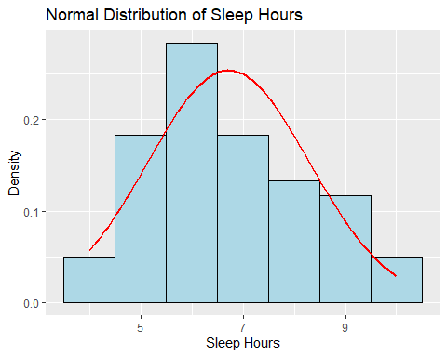

## Range Percentage  
## 1 Within 1 SD 60  
## 2 Within 2 SD 95  
## 3 Within 3 SD 100

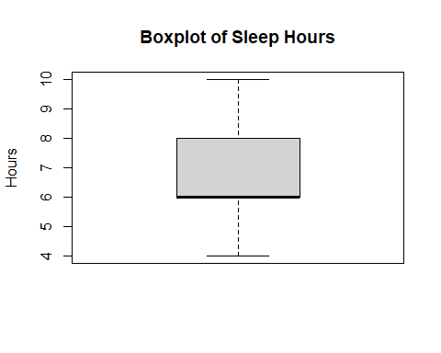

#### ***4. Interpretation***

1. **Is the distribution symmetric?**
   * The mean is around 6.72 hours and median = 6 hours, suggesting the center is around 6–7 hours.
   * The histogram and normal curve show a roughly bell-shaped distribution.
   * Overall, it’s **approximately symmetric**, but with minor leftward skew.
2. **Are there outliers?**
   * Boxplot shows no extreme outliers beyond the whiskers.
   * All data points fall within 3 standard deviations.
   * While 4 hours appears low, it’s still within expected variation.
3. **What does the shape of the distribution imply?**
   * The peak around 6–7 hours suggests **most students average slightly below recommended sleep** of 7-8 hours.
   * The shape shows few are extreme long sleepers 11+; variation is more on the shorter side since college campus setting.
   * **1-2 Hours** of less sleep will eventually take toll sometime but as long at we are getting 5-6 hours its seems fine based on standard deviation data
4. **How can this data be useful?**
   * Identifies **typical sleep patterns** in FEU or regular college campus.
   * Helps health services **target interventions** and promote sleep management to those at 4-5 hours of sleep.
   * **Promoting time management** and learning how students sleep.
   * **Baseline data** for comparing across semesters or demographics.
5. **Real-Life Implications or Recommendations**
   * Recommend awareness programs on **healthy sleep habits**.
   * Suggest academic policy reviews to **balance workload and reduce burnout**.
   * Propose student workshops on **stress management and time planning**.
   * The **importance of sleep** for mental health, academic performance, and physical wellness.